We, the Board of Directors
Of Diabetes Federation of Ireland commit to:

Principle 1
Leading our organisation. We do this by:
- Agreeing our vision, purpose and values and making sure they remain relevant;
- Developing, resourcing, monitoring and evaluating a plan to make sure that our organisation achieves its stated purpose;
- Managing, supporting and holding to account staff, volunteers, and all who act on behalf of the organisation.
Principle 2
Exercising control over our organisation. We do this by:
- Identifying and complying with all relevant legal and regulatory requirements;
- Making sure that there are appropriate internal financial and management controls;
- Identifying major risks for our organisation and deciding ways of managing the risks.
Principle 3
Being transparent and accountable. We do this by:
- Identifying those who have a legitimate interest in the work of our organisation (stakeholders) and making sure that there is regular and effective communication with them about our organisation;
- Responding to stakeholder’s questions or views about the work of our organisation and how we run it;
- Encouraging and enabling the engagement of those who benefit from our organisation in the planning and decision making of the organisation.
Principle 4
Working effectively. We do this by:
- Making sure that our governing body, individual board members, committees, staff and volunteers understand their role, legal duties and delegated responsibility for decision-making.
- Making sure that as a board we exercise our collective responsibility through board meetings that are efficient and effective;
- Making sure that there is suitable board recruitment, development and retirement processes in place.

Principle 5
Behaving with integrity. We do this by:
- Being honest, fair and independent;
- Understanding, declaring and managing conflict of interests and conflict of loyalties;
- Protecting and promoting our organisation’s reputation.

We confirm that our organisation is committed to the standards outlined in these principles. We commit to reviewing our organisational practice against the recommended actions for each principle every year.

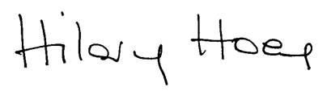
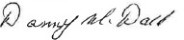
______________________ ______________________
Chairperson of Board Secretary of Board

Date: 26 February 2024

